Project Title :- **Hisac Air  
  
Aim :-**  
The aim of this project is to develop a data visualization app capable of efficiently handling large datasets, optimizing API performance, ensuring a seamless user experience, and plotting data for all channels in less than 10 seconds, even when there are 100,000 data points for each channel.  
  
**Description :-**  
This POC showcases a robust data visualization application designed to handle large datasets with performance. It incorporates essential features such as dual cursors for precise data analysis, the ability to swap cursor positions, toggling channel visibility for focused analysis, smooth zoom and panning controls for detailed exploration, and an undo option to revert zoom changes. Additionally, the app allows users to reset the graph to its original state, view cursor pointer values for accurate data interpretation, and communicate seamlessly with hardware through socket connections. Data is efficiently stored and managed using an SQLite database, supporting CRUD operations. Users can also download graph images and import/export data from/to a single file, & baseline functionality.  
  
**DCRM Test - Critical Time :-**Channel Count = 36  
1,00,000 data points for each channel => 100000 * 36 = 36,00,000 **1. Laptop**

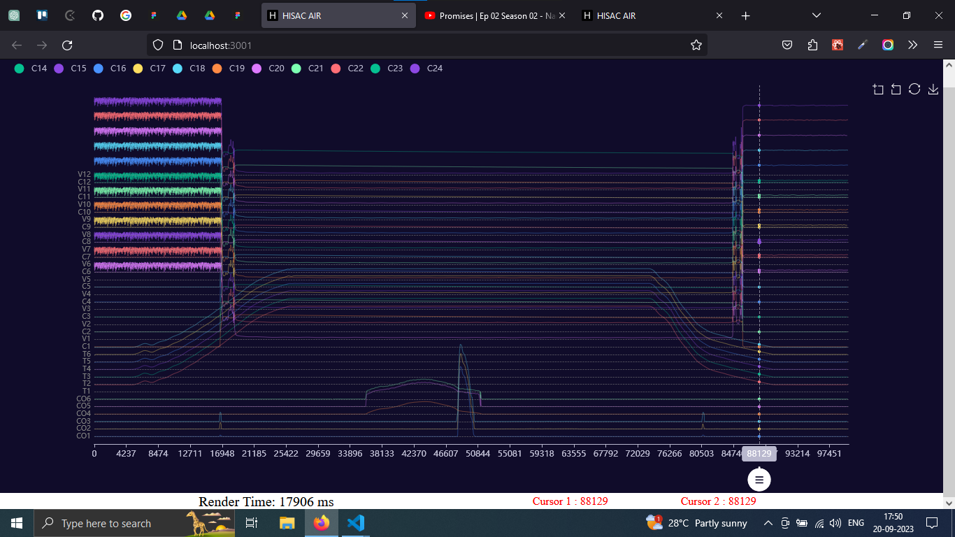

**2. Hardware**1. Old Hardware:- 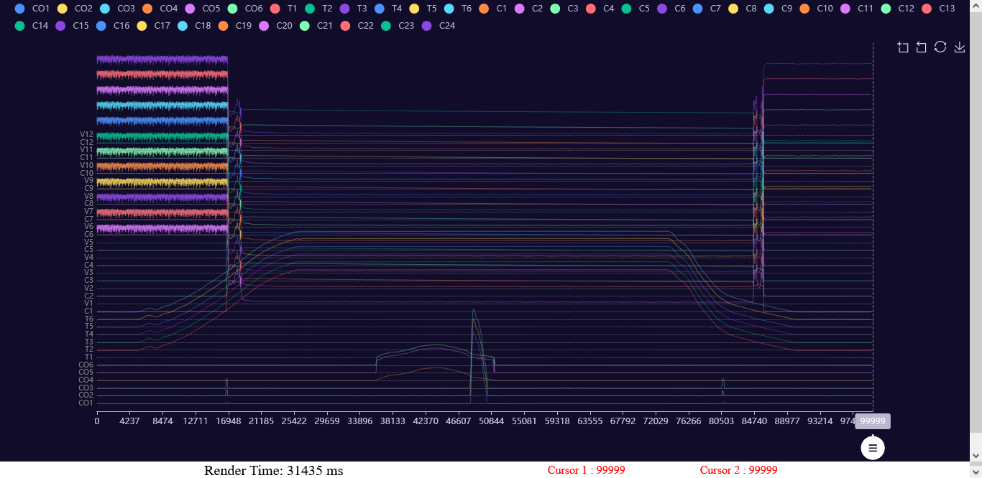

2. New Hardware:-  
**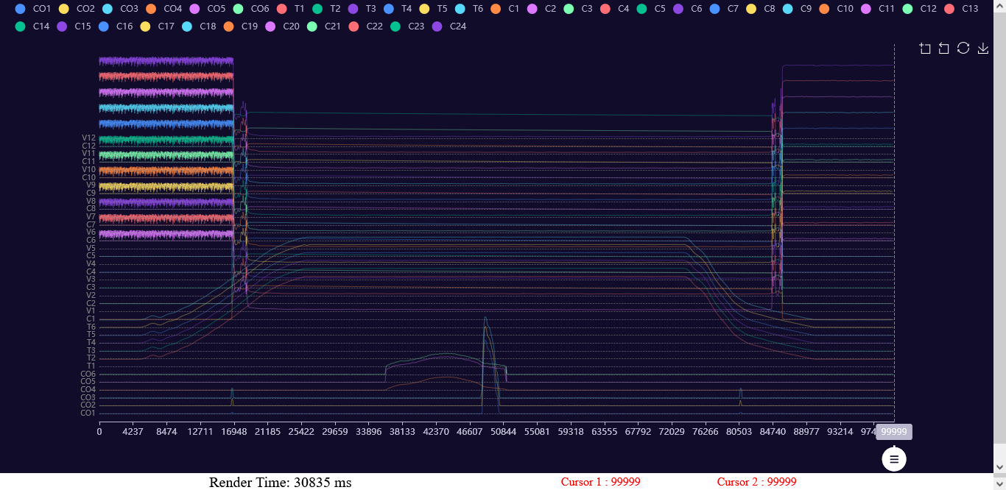  
  
  
Timing Test - Critical Time :-**Channel Count = 54  
1,00,000 data points for each channel => 100000 * 54 = 54,00,000

**1. Laptop  
  
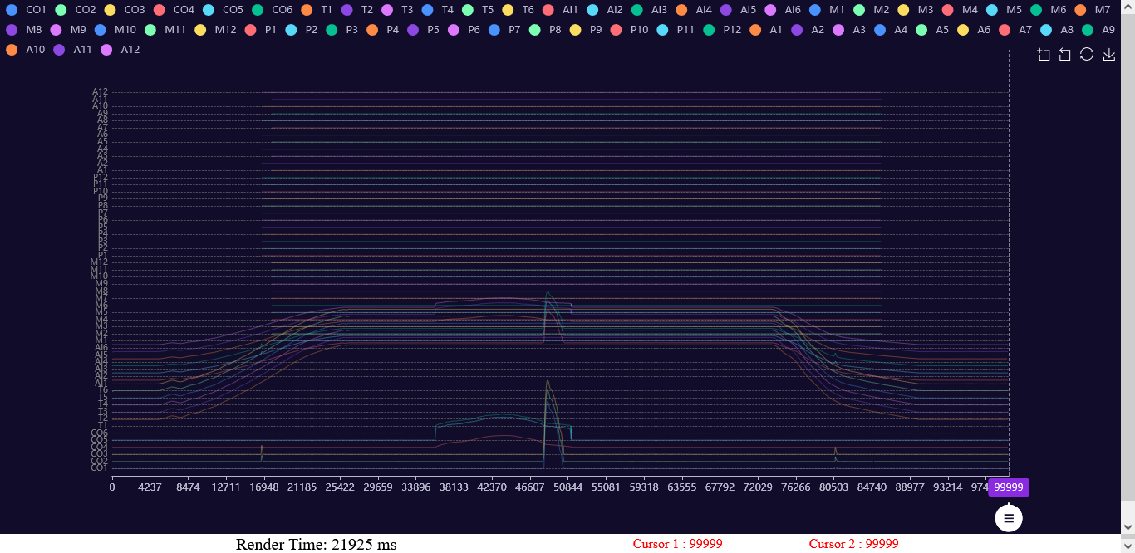**

**2. Hardware**1. Old Hardware:- 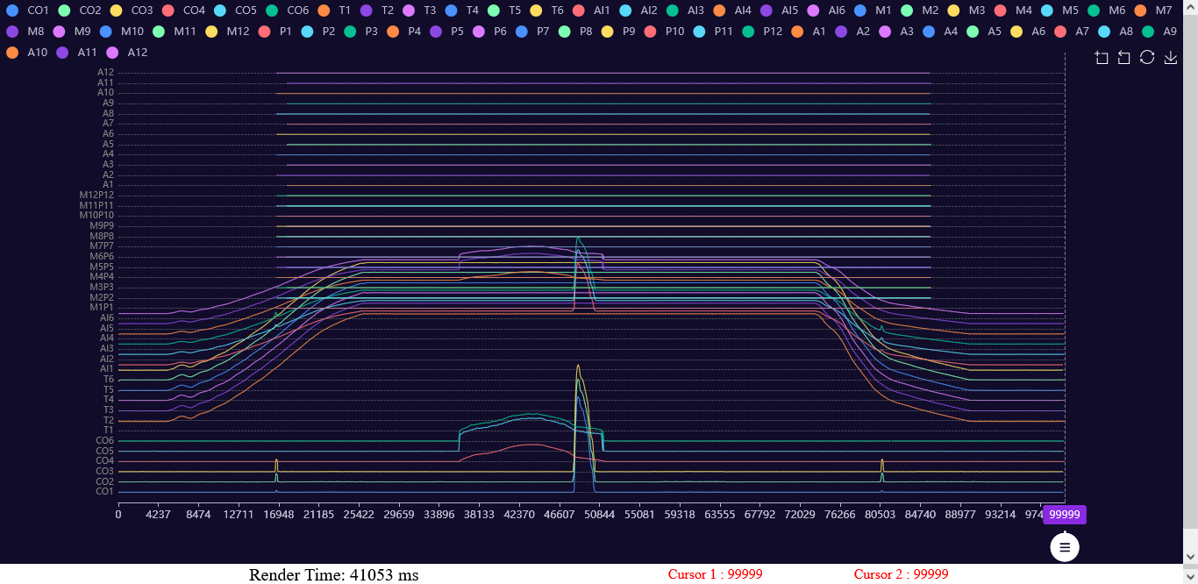  
  
2. New Hardware:-

**Conclusion :-**This Proof of Concept (POC) demonstrates the feasibility of creating a robust data visualization application capable of handling large datasets efficiently. While the application's functionality meets the desired criteria, it's worth noting that the data plotting process takes approximately 20 to 25 seconds, with varying speeds dependent on the processor used. This POC lays the foundation for further optimization and refinement to ensure a seamless user experience in future iterations.